**Ansible 201 Project Case Study**

**Firstly we will be creating one linux VM instance on google cloud as follows and install ansible on it.**

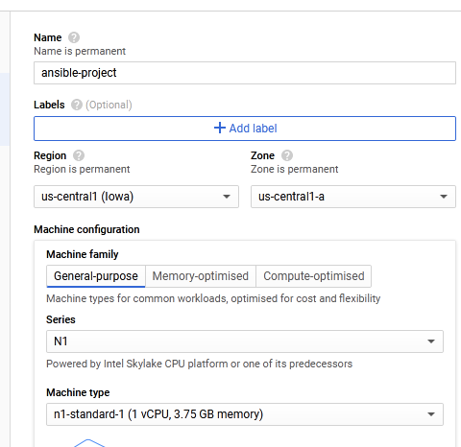

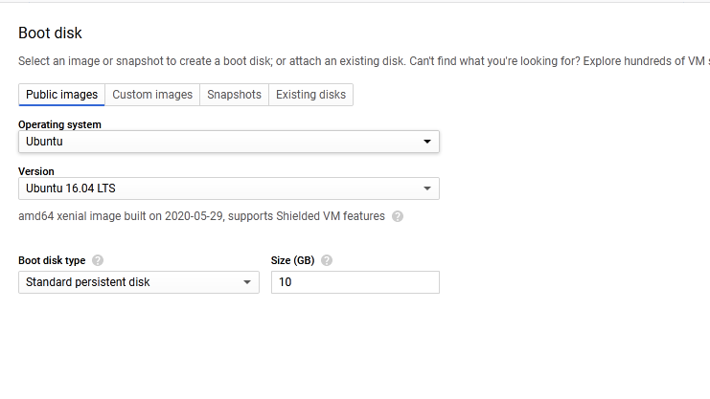

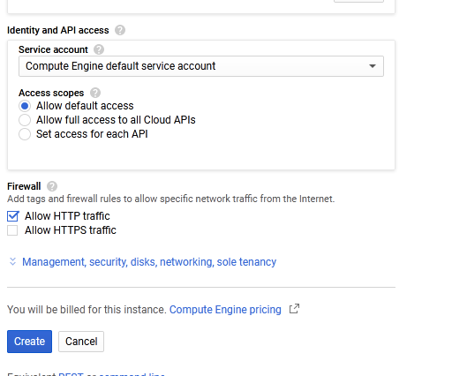

**We could see the instance created as follows**

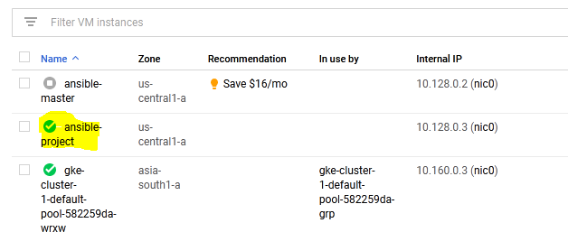

**Now we will be connecting to that VM instance thru ssh and will be installing ansible as follows.**

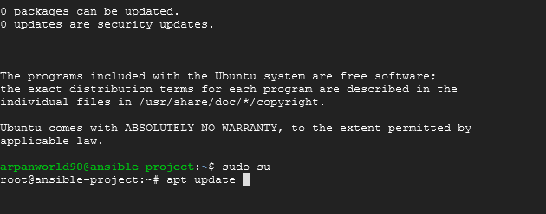

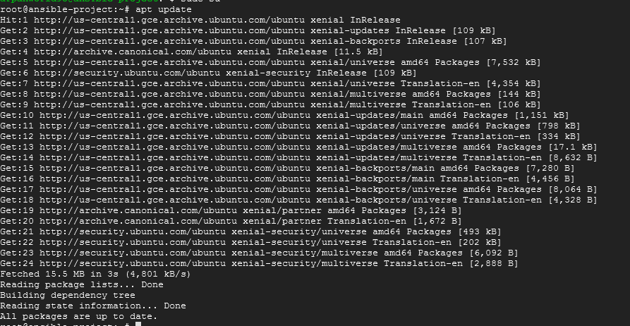

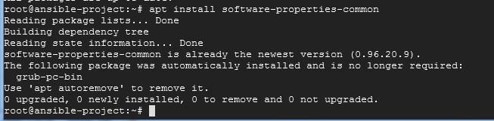

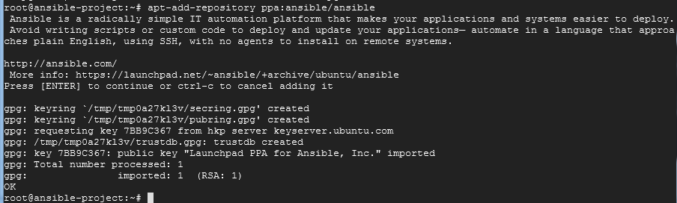

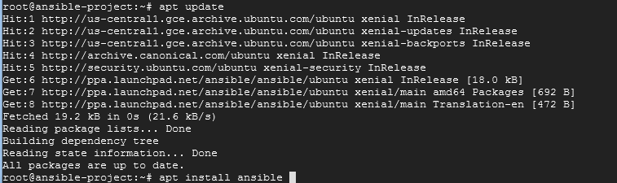

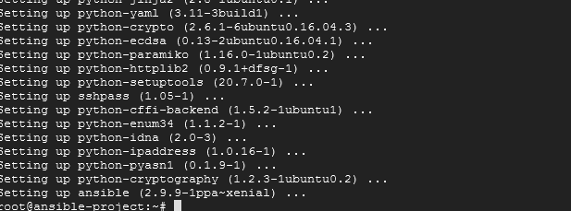

**To check whether the ansible is installed or not**

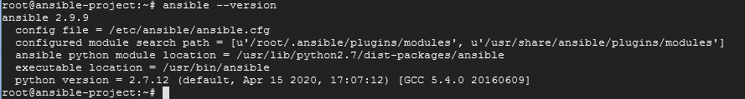

Establish SSH key pair in linux system to have SSH connectivity with localhost using following commands

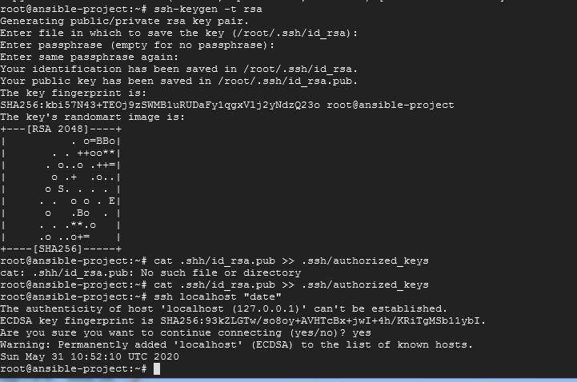

1. **Write ansible playbook for automating the tack of doing weekly system reboots.**

**Firstly we will be writing playbook for preboot tasks as follows**

**We will be installing vsftpd package in our server as a part of preboot task**

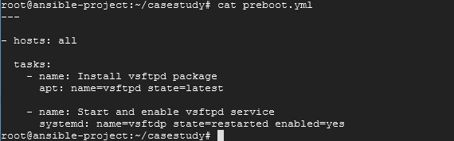

**Check for syntax errors**



**We will also be placing the hosts ip address or the host url in /etc/ansible/hosts file.**

**Here we have created an entry or the local host in the hosts file**

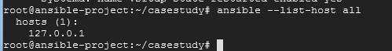

**Now we will be executing the playbook as follows**

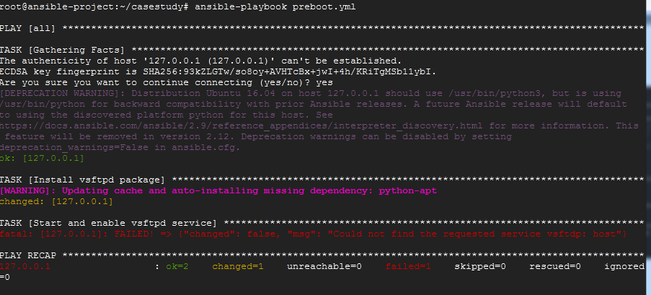

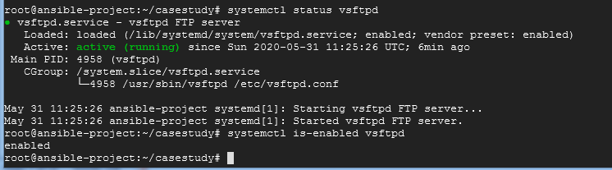

**Now we will be writing the playbook for rebooting the server as follows.**

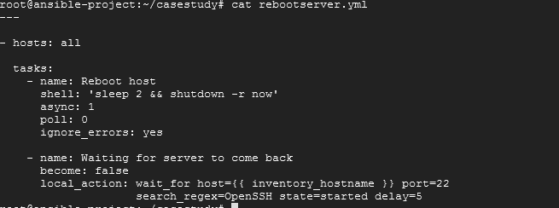

**We will be running the reboot playbook now as follows**

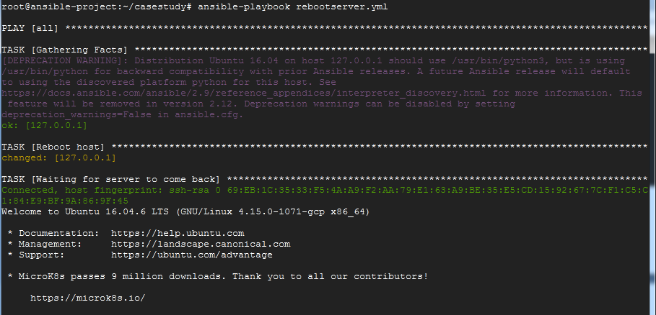

**As we are rebooting localhost it self the connection to the server will be lost for few seconds**

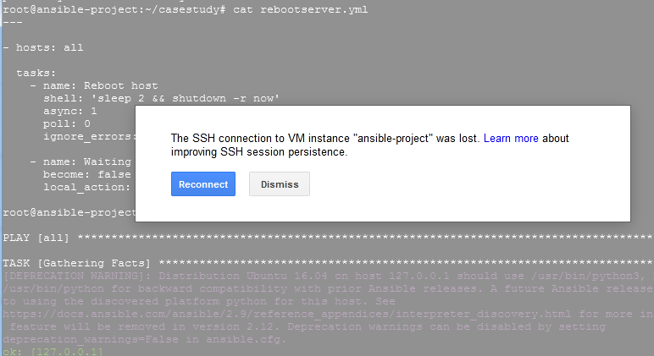

**If we add remote hosts in the /etc/ansible/hosts file the reboot will happen for that remote server as well.**

**2.Use Ansible for Enforcing security guidelines**

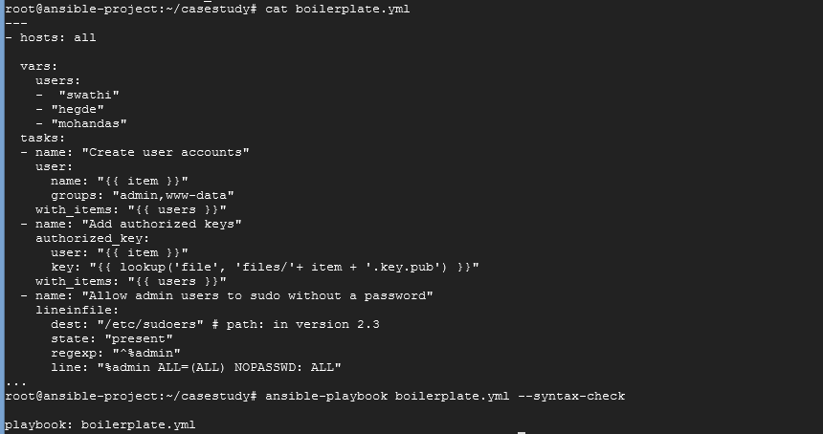

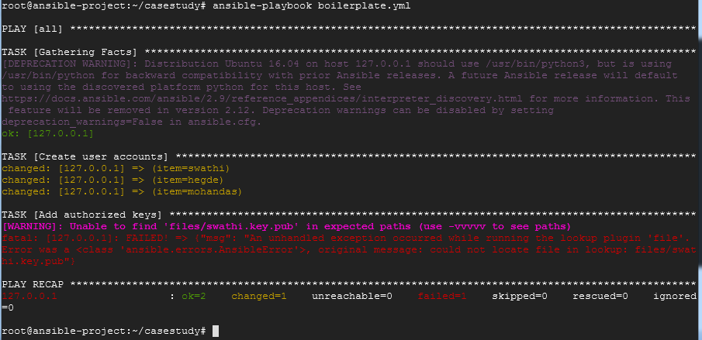

**We could see the id created and also able to login as sudo**

**We could see 3 users created**

**Cat /etc/group**

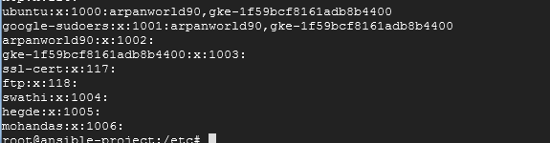

**Cat /etc/passwd**

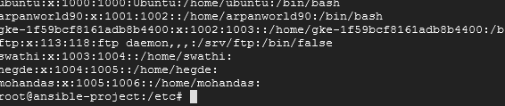

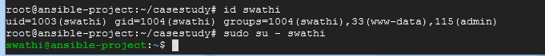

**3.Use Ansible tasks to enforce desired configuration and immediately revert using ansible roll back.**

**We will be installing ansistrano for deploying and rollback as follows**

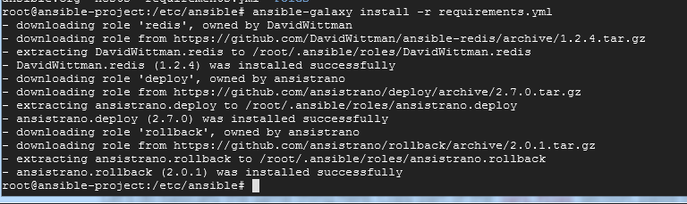

**Once the roles are installed we will be using those roles in our playbook.**

**Now we will be deploying one To-Do-List application app as follows .**

**Please find the playbook for the deploying the app**

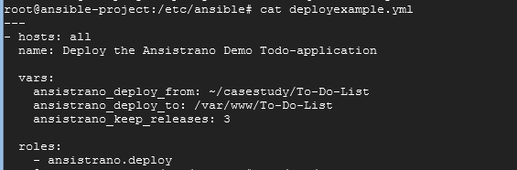

**Now we will be running the deployexample.yml as follows**

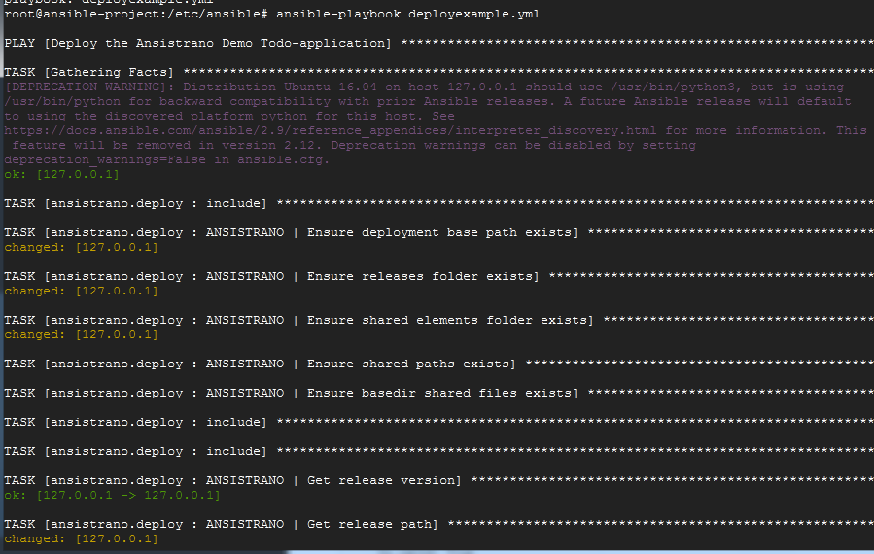

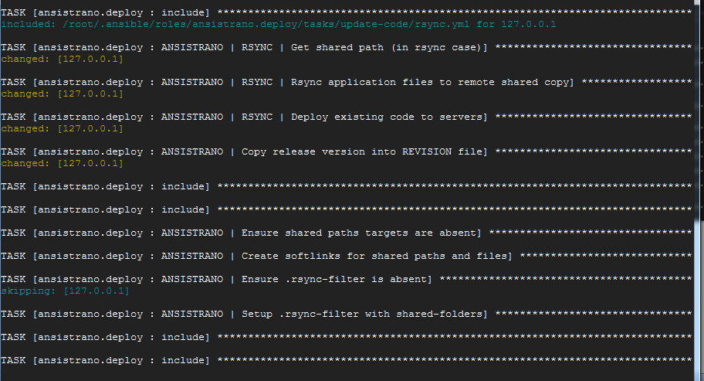

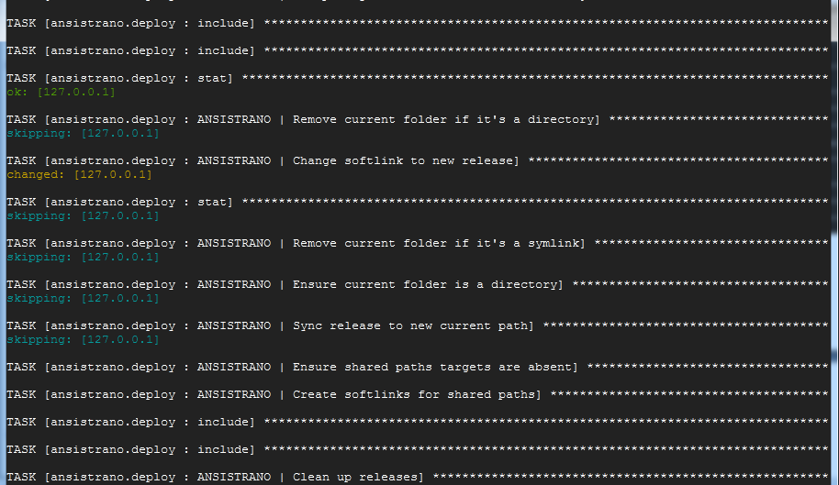

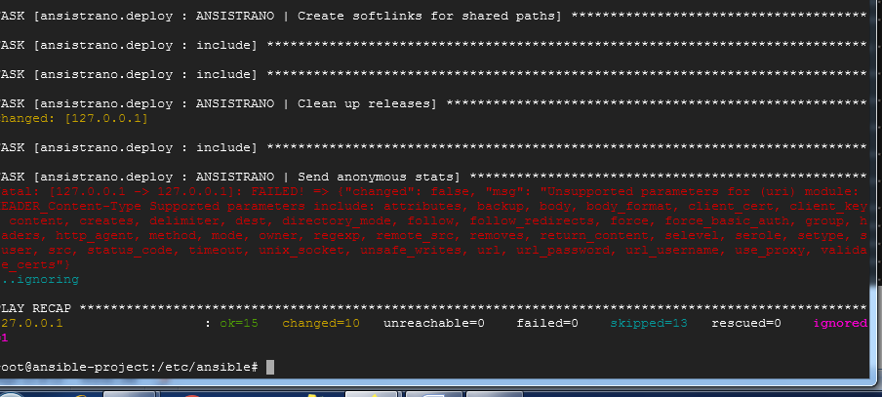

**To check whether the deployement was done successfully or not go to the /var/www the path which we have mentioned.**

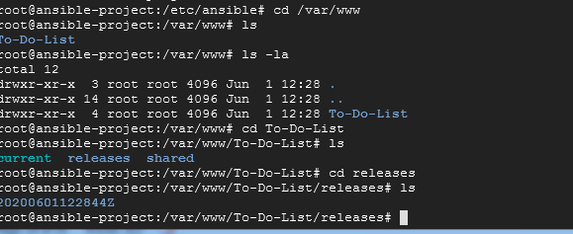

**We could see the releases.**

**Now again we will execute the deployexample.yml playbook with some changes**

**And now we could see two releases in the directory as follows.**

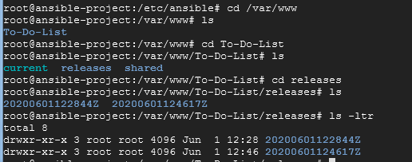

**And the current directory will be having the new changes deployed.**

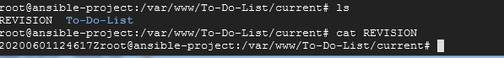

**In the revision file we can see the latest release id.**

**If we want to rollback our changes we can do that using rollback role as follows.**

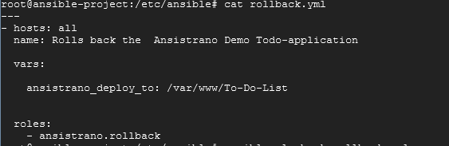

**Now we will be executing rollback.yml playbook as follows.**

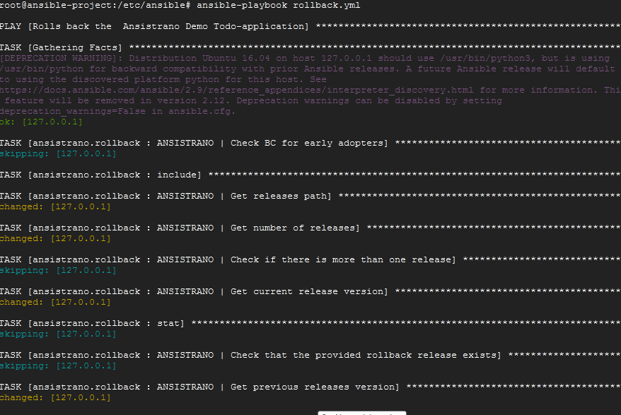

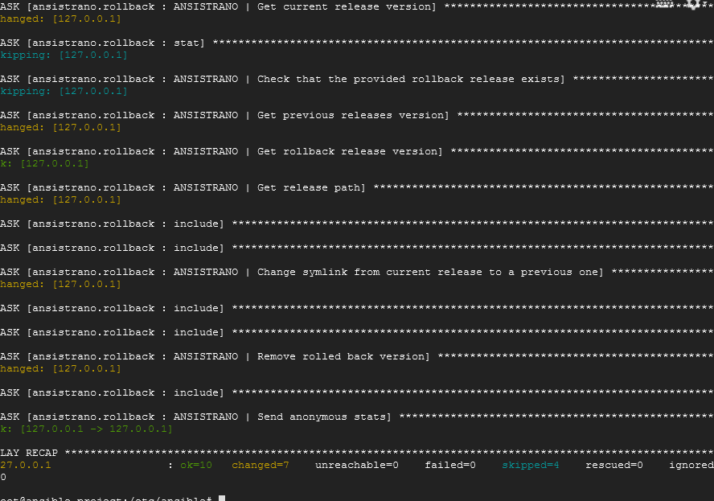

**After executing the deploy.yml we could see the following**

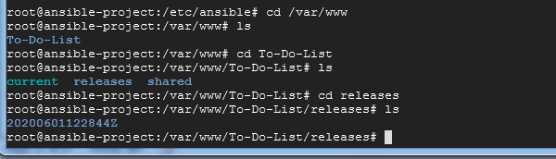

**Now we could see only one release in the release directory the previous changes were rolled back.**

**4.Ansible versioning in GIT**

**We will be writing the roles using ansible galaxy as follows:**

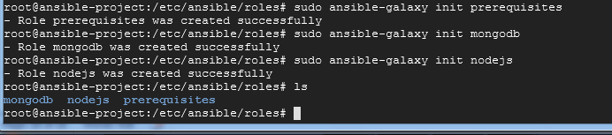

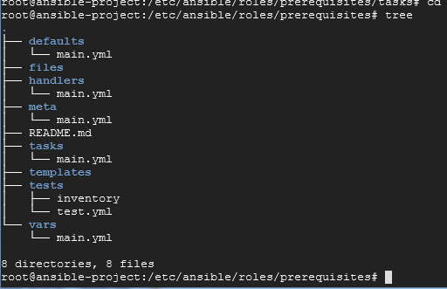

**Now we will be writing the tasks which installs git**

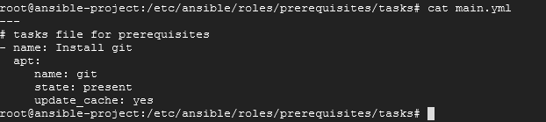

**Now we will be writing main.yml for MongoDb role**

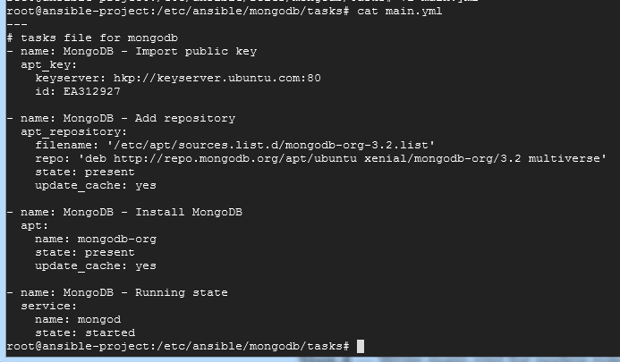

**Similarly Main.yml for nodejs**

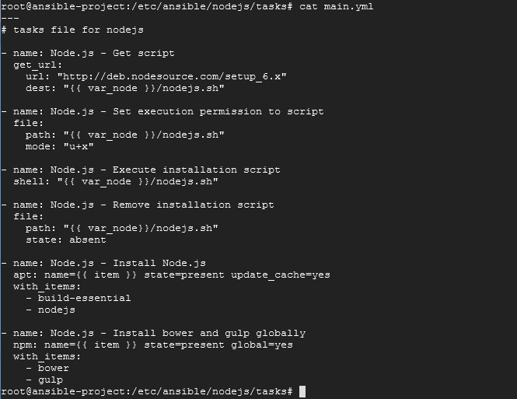

**Now we will be writing playbook for meanstack installation where we will be mentioning the above mentioned roles**

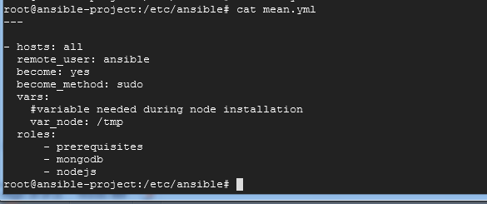

**Now we will be pushing our code to github**

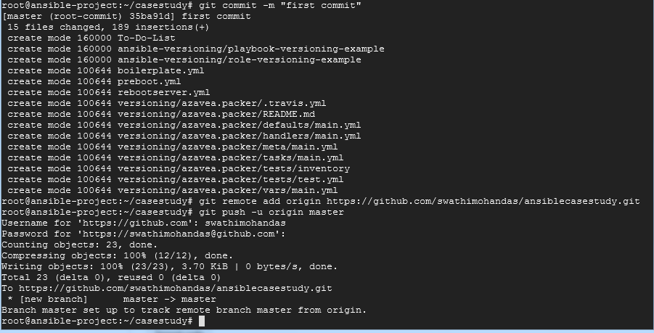

**After pushing we will be tagging the release as v1.0**

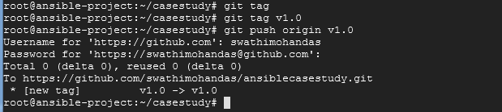

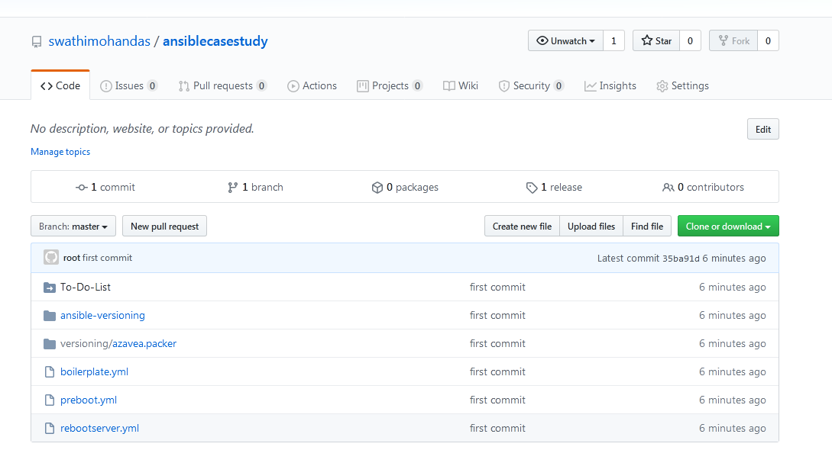

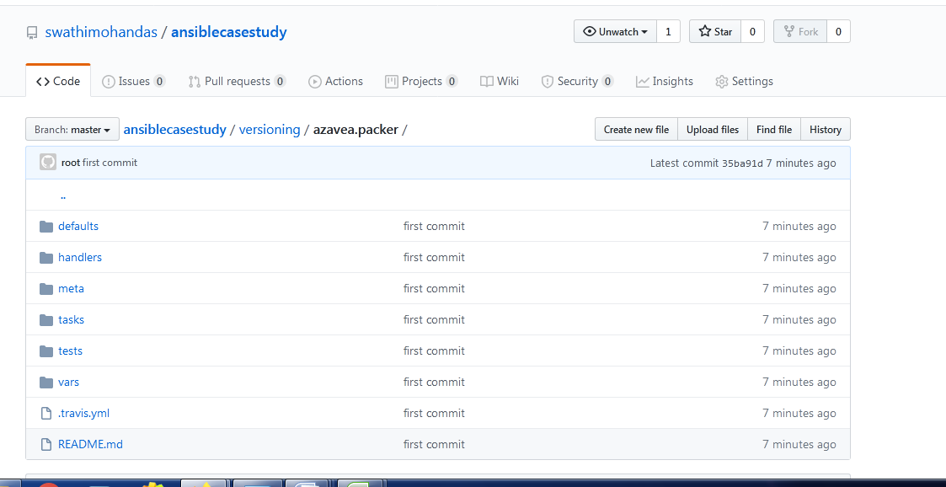

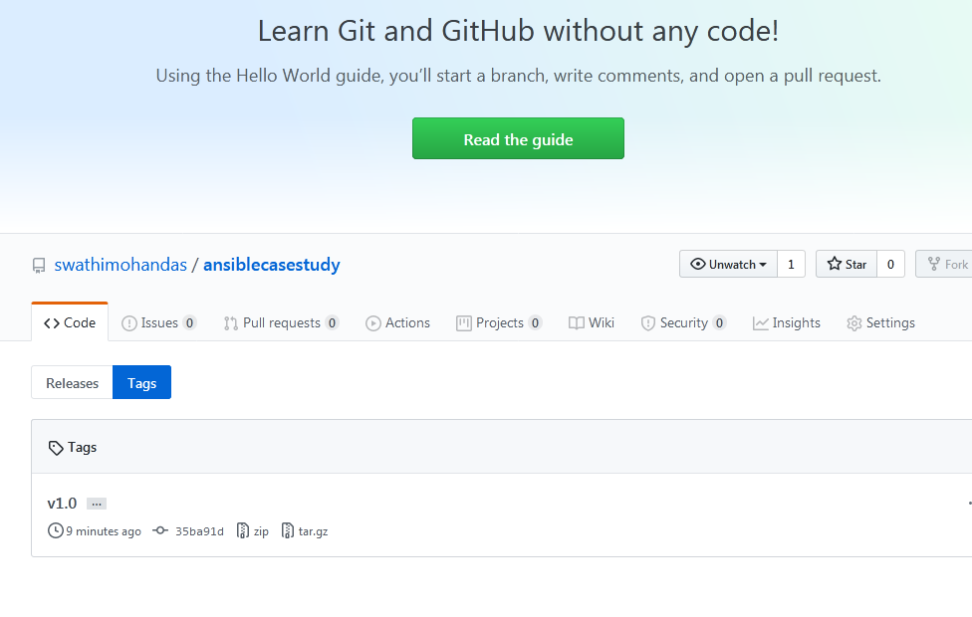

**We could see the releases as well tags**

**Sameway we will deploy few more codes and tag it as v1.1**

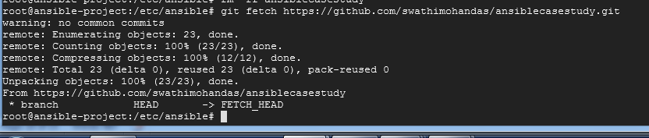

**Then we will pull**

**Then git add .**

**Then execute commit and git push commands**

**Then give the tag as v1.1**

**The result will be as follows**

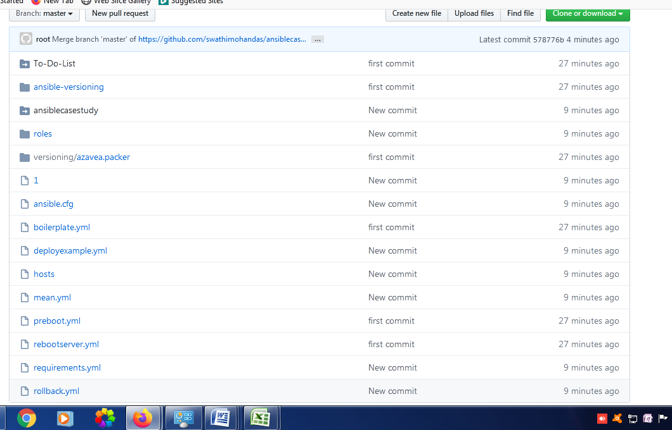

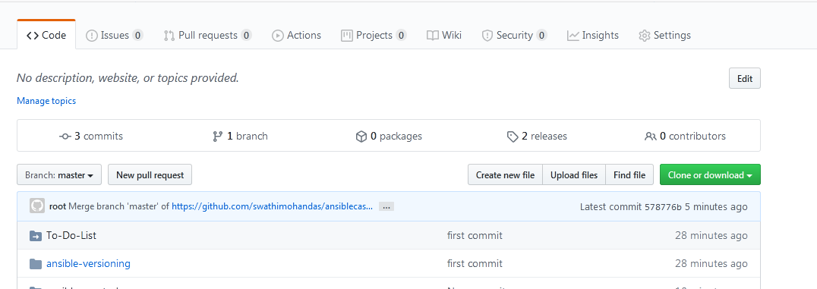

**We could see two releases as above**

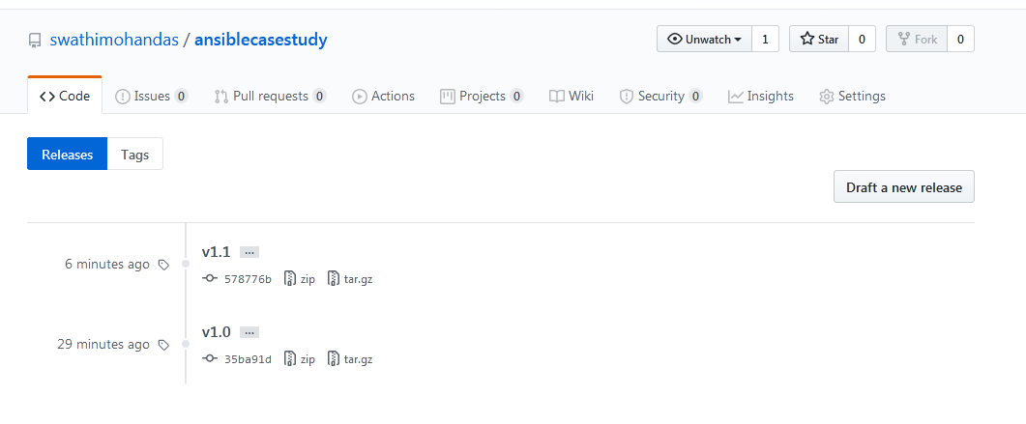

**Second release will have all files after second commit and first release will be having the code after 1st release.**

**In this way we can maintain the versioning of the ansible playbooks and roles as well in github and give the tag while referring.**